

 |  |  |  |  |  |  | 
Working on Times Table Rockstars - your child will have an individual login to access this (20 mins on SOUND CHECK).  Explore multiples through this website- hit the button.  Time for some fun!  Using your times table knowledge have a go at the game below.  Times Table Game - Tommy's Trek | Solve addition and subtraction multi-step problems in contexts.  Watch this video that explores adding numbers including decimals.  Watch this video that explores subtracting including decimals.  Choose one of the take away menus below. Can you choose a meal for your family to share based on a set budget by a member of your family. What was your total spend? How much do you have left from your budget?  Menu 1  Menu 2  Menu 3 |  | Multiply and divide whole numbers and those involving decimals by 10, 100, 1000.  Watch this video which explores dividing a range of whole and decimals numbers by 10, 100 and 1000.  Have a go at these questions linked to multiplying and dividing by 10,100 and 1000.  Ask a member of your household to set you some numbers to multiply and divide. Can you teach the skill on seesaw? |  | Recognise mixed numbers and improper fractions and convert from one form to the other  Watch this video to recap how to change mixed number fractions to improper fractions.  Watch this video to recap how to change improper fractions to mixed number fractions.  Have a go at these questions below when you’re confident.  Questions - Level 1  Questions - Level 2 | Challenge yourself to a Daily 10 Mental arithmetic challenge. Choose Level 5 and a topic area of your choice.  Top marks Challenge    Try a different topic area to cover to challenge yourself further. | 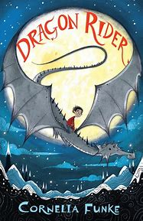  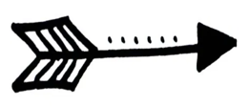  Can you click on the picture below and have a go the LIRA questions?  Literal: What is the name of the valley that the dragons lived in?  Inference: Using evidence from page 1 and 2, what do you think is happening to the dragon  Slatebeard?  Reader Response: Read page 3 and the extract below.  ‘There was nothing about it in any of their books, maybe because none of the people who had been so keen on chopping dragons’ heads off in the old days had waited around to see what happened next.’  What impression does this give of the relationship between the dragons and human beings?  Author Intent: On p1 the author introduces the character Ben Greenbloom.  ‘His eyes looked out at the world fearlessly and with curiosity’  What type of character does the author intend on building by using these words?
 |  |  |  |  |  |  | Can you click on the picture below and have a go the LIRA questions?  The Girl with the Dragon Heart  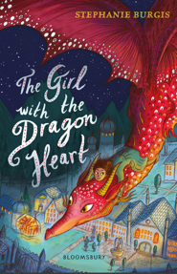 | Literal: What did the main character wave as she walked into the kitchen?  Inference: Why do you think the character preferred to wear boys’ clothes?  Reader Response: What impression does the author give you of the main character. Use evidence to support your answer.  Reader Response: What information in the text suggests the handbill is important? |  | Word Detective  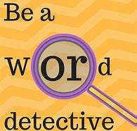  Find any words in either of the two texts that are new or unfamiliar to you. Can you find out their meaning and use them in context?  Building new words into your vocabulary is a great skill!
    Can you share your learning on or ? |  |  |  |  |  |  | 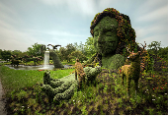  Question Time!  Click on the picture link and answer the questions attached to the picture?
 |  |  |  |  |  |  | 
    Can you share your learning on or ? |  |  |  |  |  |  |   Click the picture and watch the news report ‘Our Planet’  Can you write a news headline for the three areas covered in the report about bears, climate change and sea grass? Under each headline, write a summary of the issue covered in the news report?
Using the correct article: a or an  Can you click on the picture below and have a go at the activity?  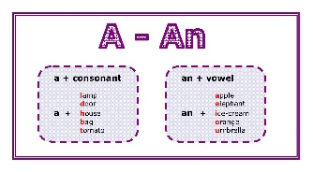 |  | Apostrophes and Contractions  Can you click on the picture below, watch the clip and have a go at the activity?  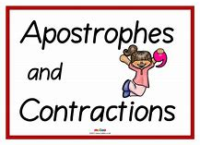 |  | Choose 5 words from the year 5/6 common exception words. Can you use them in a sentence spelling the words correctly? Write the sentences in your home learning book.  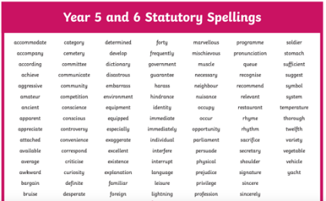  Click on the picture to link to the list. |  |  | Megacity - Story  Watch the short video advert by clicking the image below.  Retell the story in 1st person either as Jack or his dog.  Use your knowledge of first person pronouns to complete the task.  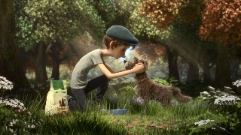 |  | 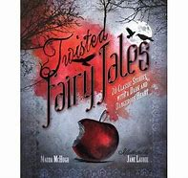  Twisted tales…  Think of your favourite traditional story that you read as a child.  Can you re write the story with a twist? How would you change the ending? Would you add any characters?  Were the 3 little pigs evil after all….

