

 |  |  |  |  |  |  |  | 
Practise your times table for x2, x5, x10, (x4)  Check out the videos below that will support you with your learning.  Multiplication x2  Multiplication x5  Multiplication x10  Multiplication x4 | Know the number of minutes in an hour and number of hours in a day.  Do you know how many minutes make up 1 hour? If not, find out here!  How many hours in a day? Watch this jingle to find out more!    The picture above has the link to the NRich website where you will find lots of challenges linked with time! Take a look and have a go! |  | Solve problems with addition and subtraction.  Problem 1: Noah saw 12 legs walk by into the ark. How many creatures could he have seen?  How many different combinations can you think of?  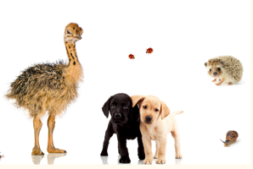  Problem 2: Butterflies and flowers.. click on the link to see this problem. Can you work it out and share your findings on seesaw/twitter?  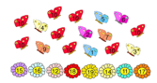 |  | Recognise and use inverse relationships between addition and subtraction.  The first part of the video models how to use the inverse for addition and subtraction. Stop the video at 2m20s.  Create your own addition calculations, the digits you choose need to be less than 20. E.g. 4 + 7 =11  Can you watch the video and write the inverse for the addition calculation as a subtraction calculation?  How many can you think of? What helps you to write your inverse calculations? |  | Compare and sort common 2d and 3d shapes and everyday objects.  Get warmed up by watching this video all about comparing 2d and 3d shapes.. How do we know which is which?  Can you create your own 2d shapes from objects around the house?  Why not get creative and think about how many different ways you could create different 2d/3d shapes!  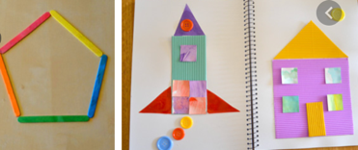  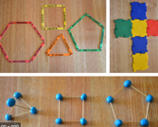  Don’t forget to  label your shapes! | 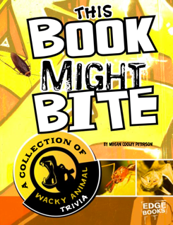  Can you click on the picture to listen to the audio book, then have a go at the LIRA questions.    Read or listen to the book  Literal: What does the word adapt mean? Use the bottom  of the page to help you.  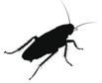  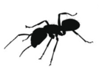  Literal: What do vampire bats do while they eat?  Literal: How much blood do bats drink in one night?    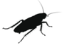  Literal: What do rabbits eat that we might find disgusting?
 |  |  |  |  |  |  |  |  | Literal: Honey ants eat so much it stops them from doing something, what is it?  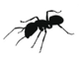  Author Intent: Why do you think the author has included pictures of the animals?  Literal: What animal burps and trumps all the time because of what they eat?  Inference: Why do you think the tiger    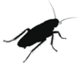  shark has a nickname  ‘waste basket of the sea’ |  | Based on the information you have read can you create several true or false questions and share them on seesaw for others to answer?  
    Can you share your learning on or ? |  |  |  |  |  |  |  |   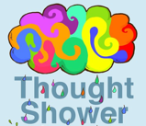  Thought shower what you have learnt from reading this book.  You could list key facts or place key facts in raindrops raining down from a huge cloud!  
 |  |  |  |  |  |  |  | 
    Can you share your learning on or ? |  |  |  |  |  |  |  |   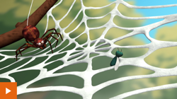  Can you click the video and follow the instructions to use  conjunctions to describe mini beasts? You could even use beasts you’ve read  about in the book above.
Capital letters and conjunctions (learn)  Can you click video below to find out how we can use conjunctions.  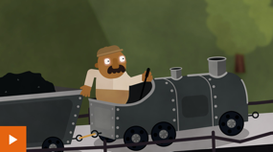 |  | Conjunctions (practise)  Imagine you are the caterpillar. Write a sentence for each of the three things you were doing using a conjunction - wriggling on a leaf, spinning in the cocoon and flapping everywhere as a butterfly.   |  | Conjunctions (apply)  Last week you used adjectives to describe your family, can you put these sentences together using conjunctions?   |  | 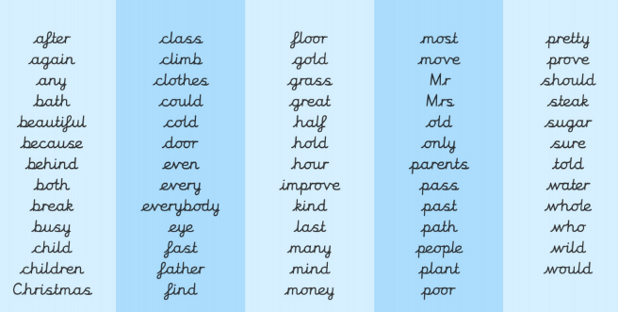  Practise the Year 2 Common Exception words you can find a link to the words on the picture below. |  |   Using the book, ‘This book may bite’ choose an animal or insect you are most interested in and create a fact file based on that animal. You may need to find out more information about that animal by using the internet. Here’s a useful website to use.  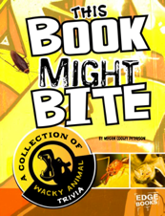   |  | Using the information you have learnt about your animal or insect can you imagine if someone wanted to keep that weird and wonderful beast as a pet? Can you create a how to guide explaining clearly how you would look after them as a pet?  What they would need to eat?  Where in the house they would be best suited?  how much exercise will they need a say?  Do they like living along or do they need company?  Is it safe to stroke them?  Does the cage need to be locked at all times?

