It is important to keep active so can you help your child think of their own exercise routine we can use at school. You could do 5 star jumps and 6 hops etc! Ensure they are always counting as they are moving.  Why not try Cosmic Kids Yoga! Hit the link below!  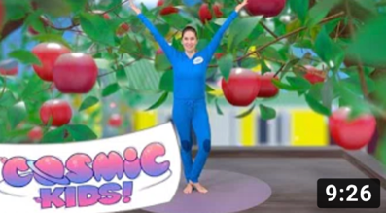 | Can you help children practise counting numbers from 0- 20. You can use lots of silly voices when you do this! Try counting quietly like a mouse or loud like a dragon and remember to become a rocket ship when you count backwards!  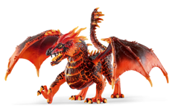 |  | If you had magic beans like Jack did who would you share them with?  Can you use different objects and imagine them as the beans and share them between your family or toys! Can you make an equal amount for each person? | Now you know where different shapes are hiding in your house, can you help your child make a tally chart recording how many of each shape you can find? You can ask questions like which shape do you see the most and which one do you see the least?  This chart could help.  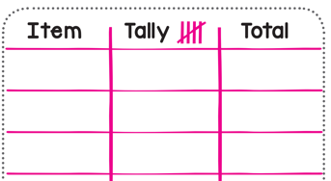 |  | Fill a cup or jar up with sweets or any small items you have in your house. Ask your child and others in your house to make a guess/estimation of how many sweets/items are in the jar. Write the estimations down. After estimating encourage your child to count out the items carefully, giving a number name for each item. Who was the closest with their estimation?  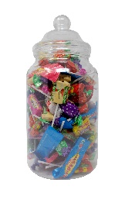 | Reception age children: Children to read to parents daily. Visit Oxford Owl for free eBooks that link to your child’s book band. You can create a free account. Complete the linked Play activities for each book.  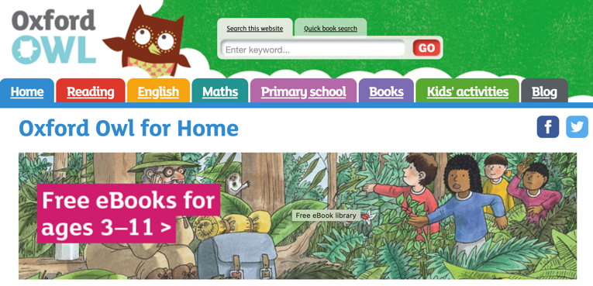
 |  |  |  |  |  |  | Now you are familiar with the traditional story ‘Jack and the Beanstalk’.  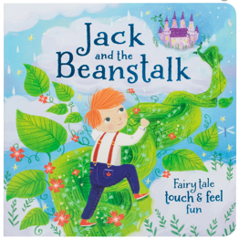 | 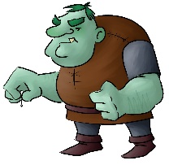  Can you draw us and label/caption your favourite character from the story.  Green hair  Gigantic hands  Pointy chin |  | Create a poster all about you- TIME TO SHINE. What makes you, you? What is your favourite colour? Your favourite day of the week and why? Who is in your family? (this can be created electronically or on paper)  Please share this so we can celebrate YOU.
Can you share your learning on |  |  |  |  |  |  | 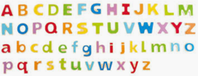  Practice name writing. Can they write their first name? Middle name? Surname?  Using chalks, crayons, paint, felt tips.
Tricky Words  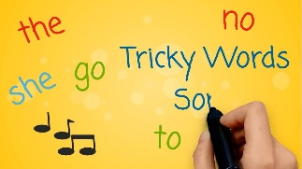  It is very important that we practice oral blending when we are reading, but we also need to become familiar with tricky words we have been learning. Listen to this tricky word song. Can you spot any of these words in your reading books? |  | Phonics Play is FREE using this log in – click this link  Username: march20  Password: home |  |  | Rhyme Time House Hunt!  Can you find any objects in your house that rhyme? The video below might help you.  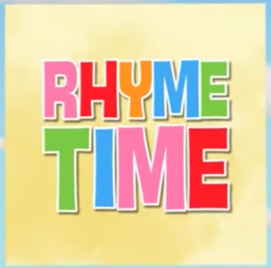 |  | Junk model :  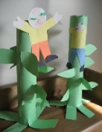  Can you create a bean stalk with any recycling items in your house: boxes, tines, plastic and paper. How will you join the resources together, what resources will you use for joining? Take a picture of your creation or a video explaining how you have created this. Your teachers may even challenge you this time. |  | Jack’s is MISSING! Can you create a wanted posted to try and find him? What does he look like? Where was he last seen? Can you draw a picture to show this? Use this poster to help you.

